Universidad del Valle de Guatemala Ángel Orellana #19095

Simulación y fabricación de PCBS José Vanegas #19125

Sección no. 10

**Proyecto Multicapa**

**Restricciones del fabricante.**

|  |  |  |  |
| --- | --- | --- | --- |
| Item | JLCPCB | NextPCB | PcbWay |
| Layer counts | 1-6 layers | 1-20 layers | 1-10 layers |
| Material | FR-4 | FR-4, Aluminum, Rogers, Copper | FR-4,Aluminum |
| Dielectric constant | 4.5(double-side PCB) | 4.2 | + |
| Max. Dimension | 400x500mm | 1-2 layers: 500*600mm  4-20 layers: 400*500mm | 500*1100mm (min 5*6mm) |
| Dimension tolerance | ±0.2mm | CNC: ±0.15mm, V-CUT: ±0.2mm |  |
| Thickness Tolerance  ( Thickness≥1.0mm) | ± 10% | ± 10% |  |
| Thickness Tolerance  ( Thickness<1.0mm) | ± 0.1mm | ± 0.1mm |  |
| Drill Hole Size (Mechanical) | 0.20mm- 6.30mm | 0.15-6.5mm |  |
| Drill Hole Size Tolerance | +0.13/-0.08mm | ≤0.05mm |  |
| Blind/Buried Vias | Don’t support | ≥ 20µm |  |
| Min. Via diameter | 0.4mm | 0.45mm |  |
| Hole size Tolerance (Plated) | +0.13mm/-0.08mm | ±0.075mm |  |
| Hole size Tolerance (Non-Plated) | ±0.2mm | ±0.05mm |  |
| Rectangle Hole/Slot | Don’t support | With or without fillet angle |  |
| 1oz Copper | 0.13mm | 3.5mil (single side) (3.5mil≈0.09mm) |  |
| 2 oz Copper | 0.2mm | 4.5mil (single side) (4.5mil≈0.11mm) |  |
| Hole to hole clearance(Different nets) | 0.5mm | ≥12mil(Avoid conductive anodic filament)(12mil≈0.30mm) |  |
| Min. Hole size | 0.2mm | 0.2mm |  |
| Via to Via clearance(Same nets) | 0.254mm | ≥8mil (8mil≈0.20mm) |  |
| Pad to Pad clearance(Pad without hole, Different nets) | 0.5mm | ≥0.40mm |  |
| SMD pad to SMD pad clearance(Pad without hole, different nets) | - | ≥0.15mm |  |
| Via to Track | 0.254mm | ≥7mil (7mil≈0.18mm) |  |
| PTH to Track | 0.33mm | ≥9mil (9mil≈0.23mm) |  |
| NPTH to Track | 0.254mm | ≥8mil (8mil≈0.20mm) |  |
| Pad to Track | 0.2mm | ≥9mil (9mil≈0.23mm) |  |
| H/HOZ (Inner layer) | 5mil (0.127mm) | 2.5mil (2.5mil≈0.06mm) |  |
| 1oz (Outer layer) | 1/2 layers: 5mil (0.127mm)  4/6 layers: 3.5mil(0.09mm) | 3mil (3mil≈0.08mm) |  |
| 2oz (Outer layer) | 8mil (0.2mm) | 5.5mil (5.5mil≈0.14mm) |  |
| Solder mask opening/ expansion | 0.5mm | ≥1.5mil (1.5mil≈0.04mm) |  |
| Solder bridge | 0.2mm(green)  0.254mm(other colors) | Green: 3.5mil  Black/White: 5mil  other solder mask: 4mil |  |
| Solder mask color | green, red, yellow, blue, white, and black. | Green/Red/Yellow/Blue/White/ Matte Black/Black | Green ,Red, Yellow, Blue, White ,Black |
| Solder mask dielectric constant | 3.8 | 3.5 |  |
| Solder mask thickness | 10-15UM | Solder mask thickness on base material: 0.8mil, solder mask thickness on copper: 0.6mil |  |
| Minimum Line Width | 6 mil (0.153mm) | Silkscreen printing≥5mil  (5mil≈0.12mm)  Printer printing≥3mil  (3mil≈0.08mm) |  |
| Minimum text height | 32 mil (0.8mm) | Silkscreen printing≥30mil (30mil≈0.76mm)  Printer printing≥24mil (24mil≈0.61mm) |  |
| Character width to height ratio | 1:6 | ≥ 6:1 |  |
| Pad To Silkscreen | 0.15mm | >6mil (6mil≈0.15mm) |  |
| Trace to Outline | 0.2mm | 0.2mm |  |
| Trace to V-cut line | 0.4mm | 0.4mm |  |

**Cotizaciones:**

**Next PCB:**

**Fabricación**

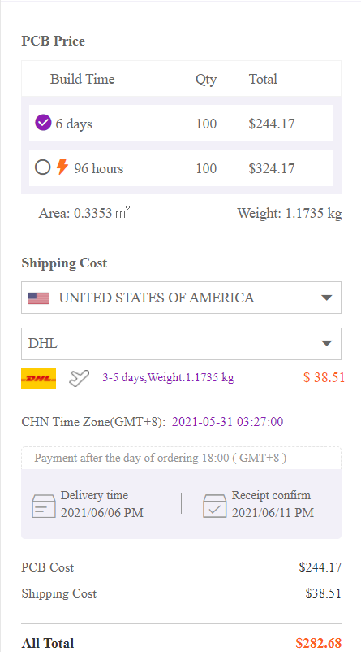

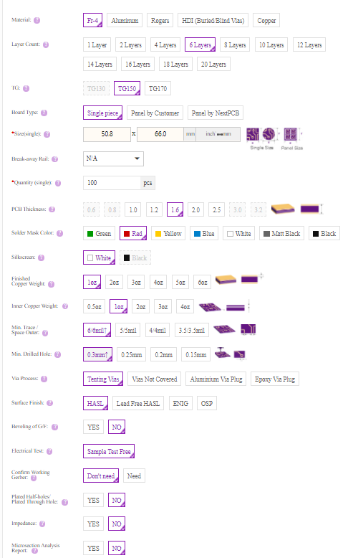

Ensamble:

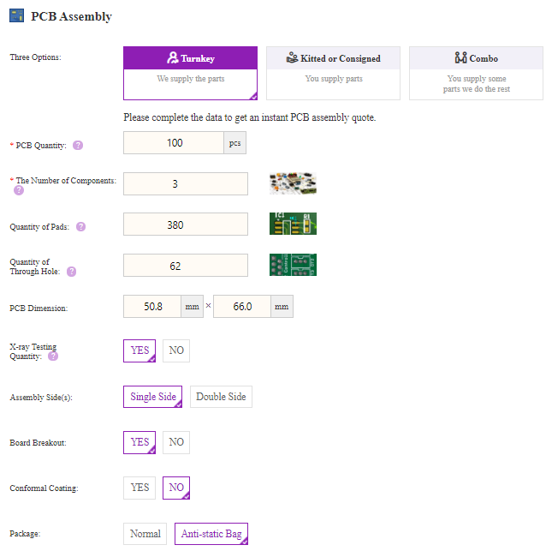

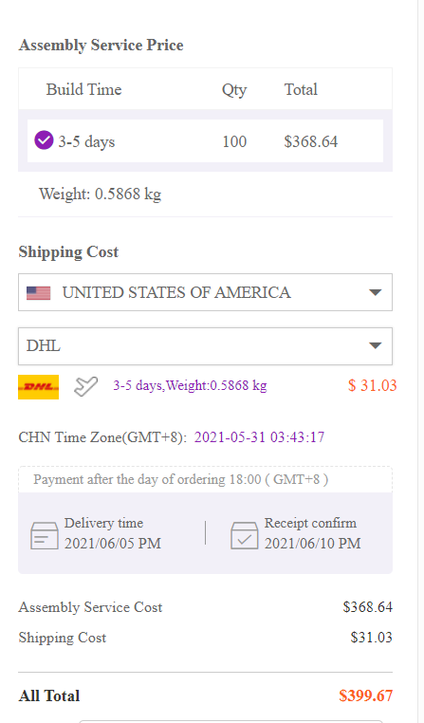

**PCB way:**

Fabricación

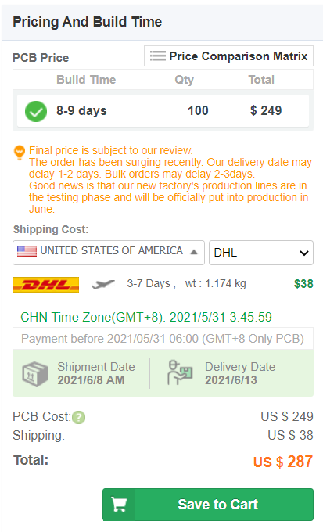

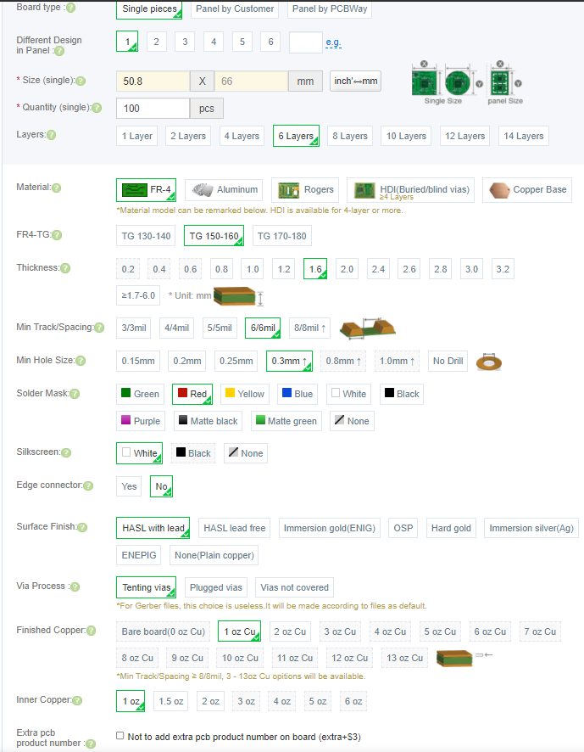

Ensamble

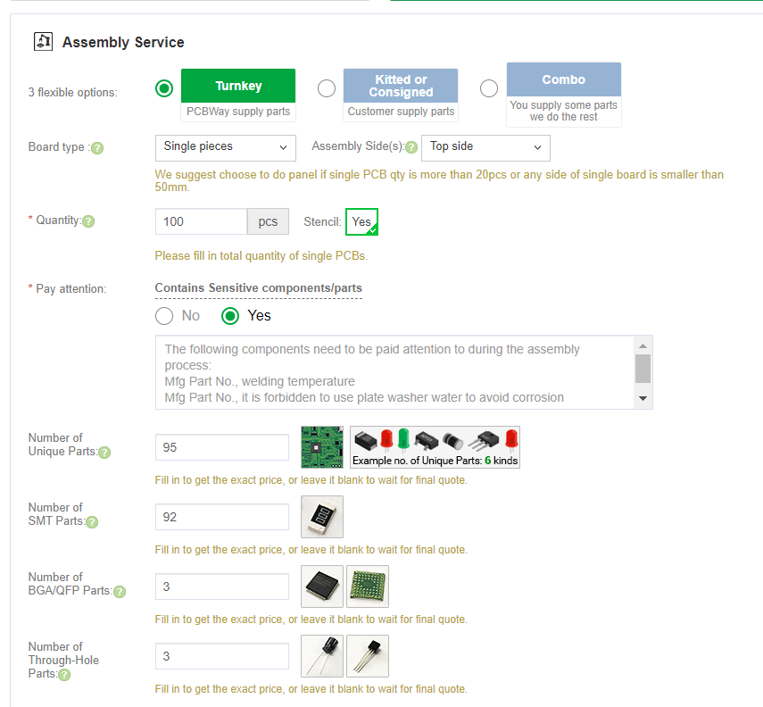

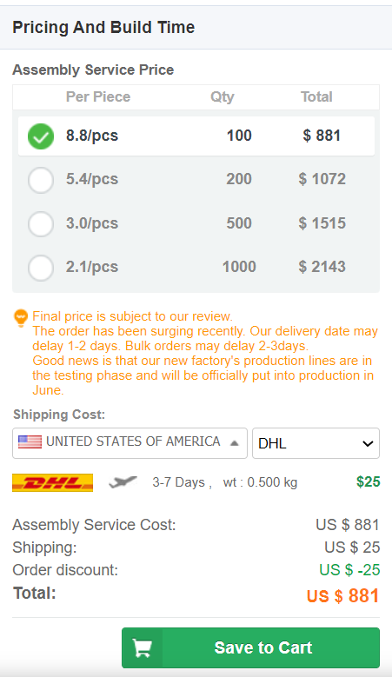

* En JLCPCB no es posible fabricar ya que no pueden fabricar PCB con vías enterradas.